DATE | 20-02-2026
TEAM ID | LTVIP2026TMIDS90622
PROJECT NAME | SMART SORTING : TRANSFER LEARNING FOR IDENTIFYING ROTTEN FRUITS AND VEGETABLES
MAXIMUM MARKS | 2 MARKS

6.2 DATA COLLECTION
Collect the data-set:
It is the most crucial aspect that makes algorithm training possible. So, this section allows you to download the required dataset.
Activity 1: Download the dataset
There are many popular open sources for collecting the data. Eg: kaggle.com, UCI repository, etc.In this project, we have used 28 classes of fruits and vegetables data. This data is downloaded from kaggle.com or can be connected by using API. Please refer to the link given below to download the dataset.
Link: Dataset
Fruit and Vegetable Disease (Healthy vs Rotten)
As the dataset is downloaded. Let us read and understand the data properly with the help of some visualization techniques and some analyzing techniques.
Note: There are several techniques for understanding the data. But here we have used some of it. In an additional way, you can use multiple techniques.
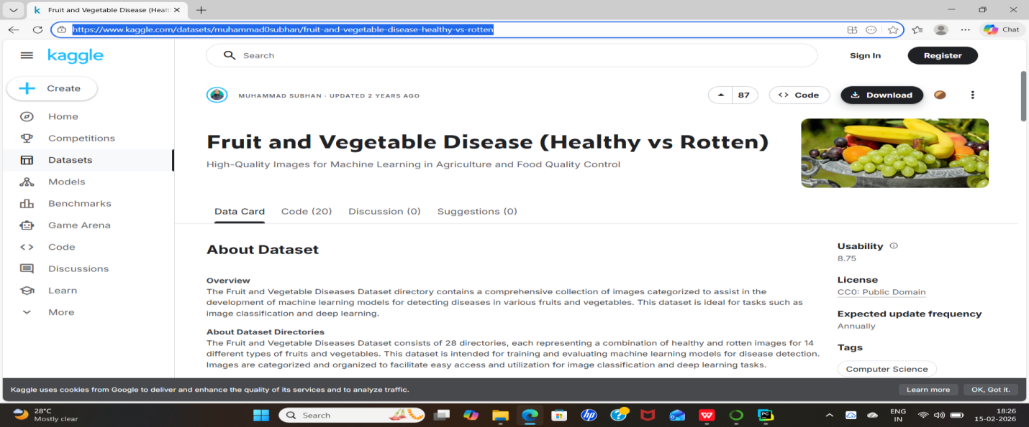
IMPORT THE FOLLOWING LIBRARIES :
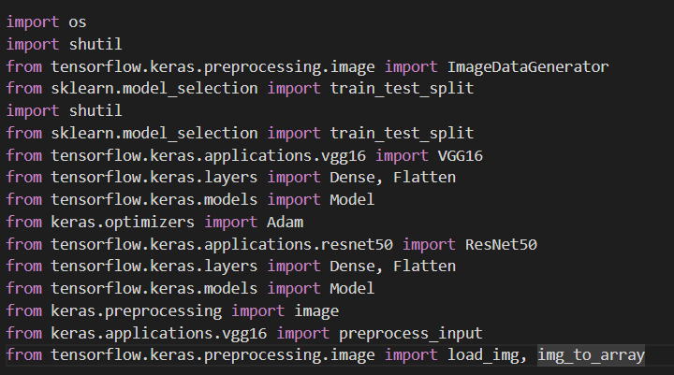
READ THE DATASET :
Our dataset format might be in .csv, excel files, .txt, .json, or zip files, etc. We can read the dataset with the help of pandas.
At first, unzip the data and convert it into a pandas data frame.


